WRITING STRATEGIES

PROCESS

• Follow the same initial steps for writing about a graph.
• In the introduction you can use:
The diagram/picture/chart shows/illustrates/describes/ depicts the process of/how ...
• Find a starting point and write the process as a series of steps.
• Useful connecting words you can use are:
- Adverbs: first/firstly/first of all, secondly, thirdly. then/next/after that/following that/ following on from this/subsequently/subsequent to that, finally
- Prepositions: At the beginning of ... ; At the end of ...
• Use the following conjunctions to make more complex sentences:
- when/once/as soon as/immediately
- before + clause or gerund
- after + clause or gerund
- where/from where/after which
• Other connecting devices you can use are:
- The first/next/final step/phase/stage is/involves
- After this step ...
- Once this stage is completed
- Following this ...
• In sequences, you can also use the gerund to show development.
• Use the present simple to describe processes.
• The agent is not usually mentioned unless a task is performed by a particular person.
• Use the passive voice if the process is describing something being made, like a book, e.g. the book is printed and then collated, after which it is bound.
• Use the active voice when you describe something which is happening:
The moisture evaporates and condenses on the ...
• Be very careful with singular and plural agreement in writing processes especially if you are using the active voice.
• When describing a cycle, you can conclude:
The cycle then repeats itself / is then repeated.
• See video to get more information: https://www.youtube.com/watch?v=KNXvnbxU61w

The diagram below shows how electricity is generated in a hydroelectric power station.

Summarise the information by selecting and reporting the main features, and make comparisons where relevant. Write at least 150 words.

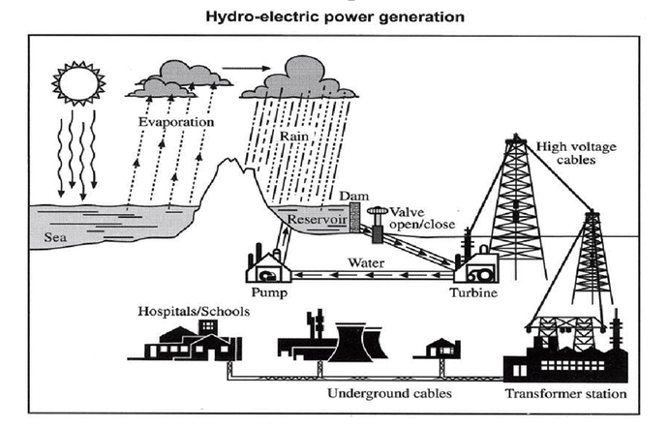

Kabdenov Mukhamed 21МЭЛ 2П

The given diagram illustrates the process of electricity generation on hydro-electic power plant.
First of all, water heated by sun should evaporate from the sea and then turn into a precipitation to fill the reservoir which created with the help of dam.
The next step, will be the transportation of water from reservoir to the turbine that depends on a valve’s position. If the valve is in the open position water flows to the turbine, where after producing the electricity will be pumped back to the reservoir by water pump.
That mechanism ensures the cyclical nature of the electricity production process.
After all of that, generated power should be transmitted by the cables that can withstand high voltage to the transformer station.
In the final stage, electricity is delivered to consumers such as schools, hospitals, factories and even houses via cables that buried underground.
Once the electricity is delivered to consumers, it can be used for their benefit.
(158 words) 30 min

